Canyonville Christian Academy
2017 Track Schedule

Updated March 8, 2017, version 3.0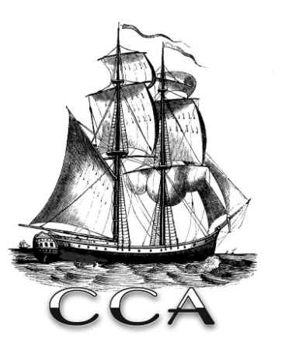

Date | Day | Meet
3/17 | Friday | 3/17 Warrior Relay ( Oakridge) 1:00pm (arrive at 12 noon) bus loads @ 10:40am
4/4 | Tuesday | 4/4 Oakland Home (Oakland) 4:30pm (arrive at 3:30) bus loads @ 2:30
4/8 | Saturday | 4/8 Glide/Maynard Mai (Glide) 11:00am (arrive at 10am) bus loads @ 9am
4/10 | Monday | 4/10 No Wimps (Riddle) 4:00pm (arrive at 3pm) bus loads @ 2:45
4/15 | Saturday | 4/15 Prefontaine (Coos Bay) 10:00am (arrive at 9am) bus loads @ 7am
4/20 | Thursday | 4/20 Jack Blum (Reedsport) 4:00pm (arrive at 3pm) bus loads @ 1pm
4/25 | Tuesday | 4/25 Far West JV Meet (Winston) 4:00pm (arrive at 3pm) bus loads @ 2:10pm
4/28 | Friday | 4/28 South Umpqua (Myrtle Creek) 3:15pm (arrive at 2:15pm) bus loads @ 2pm
5/2 | Tuesday | 5/2 Cinder Classic (Eugene) 4:00pm (arrive at 3pm) bus loads @ 1pm
5/5 | Friday | 5/5 Oakland Twilight (Oakland) 5:00pm (arrive at 4pm) bus loads @ 3pm
5/13 | Saturday | 5/13 Mountain View Districts (tbd)
May 18th | Thursday | OSAA 2A State Championships – U of O (tbd)
May 19th | Friday | OSAA 2A State Championships – U of O (tbd)

Head Coach – Devon Carrol
Assistant Coach – Jessica Johns
Athletic Director – Lance Nutter
Principal – Daron Patton
Phone: (541) 839-4401

